Comments on this link:
Supply Chain Intel Hub

Global Spend Analysis
- In the “All Entities” filter, it seems it is not the same list as entities in the Supplier Marketplace tab, as it is reading 20 entities here but in the supplier marketplace it is reading 19. What is the entity “CENTRICO”? Also the filter is not working, the data is not changing when I filter by entity.
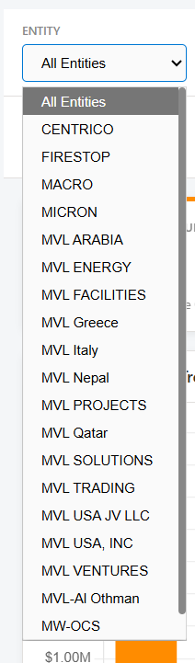

- In the field “All Suppliers”, currently not all suppliers are appearing, only some of the names that start with the letter A and B. We need this list to be in alphabetical order, have all the suppliers, and also have the capability for us to write some key word (part of the name) so that it filters the corresponding names. Also seems the filter is not working, so if I filter by supplier it is not changing the data.
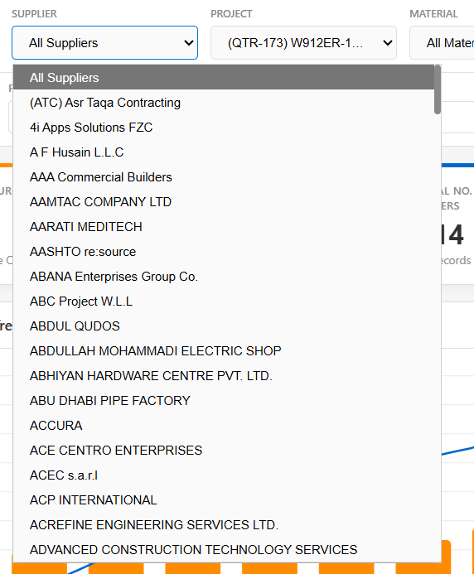

- In the “All Projects” filter, I think this is already in alphabetical order but are we able to use the drop-down and also write a word from the project so that it detects the corresponding project similar to point no. 2 above? Also seems the filter is not working, so if I filter by project it is not changing the data.
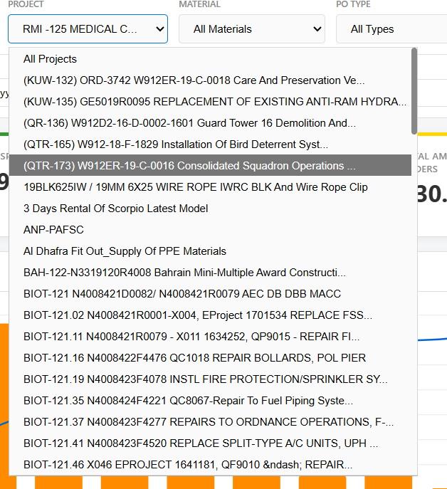

- The filter “All Materials” is not reading all the material (only 14 out of 30 being read). All Materials should account for 30 materials. So firstly, the filter All Materials should reflect 30 materials, in alphabetical order and also it should allow the user who is filtering to type the material name. Also seems the filter is not working, so if I filter by material it is not changing the data.
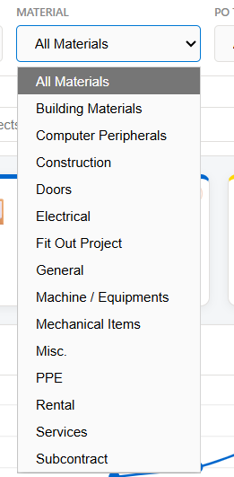

- PO Type:
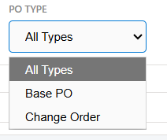
It seems the filter is not working, so if I filter by type, it is not changing the data. Note that if we choosing Base PO, it should filter as only base POs (RFPOs ending in -1)
- Years:
Here the YEAR field should start from 2010 till date as there are no orders before 2010. So 2010 till 2026. The From and To should also be like that start from 1 January 2010 till date. And the cap of this date should be automatically updated depending on which day we are so that we do not keep on updating it. The user should not be able to chose a date beyond today for the filtering. Currently, none of the 3 fields “YEAR”, “FROM” and “TO” is working as the data is not changing accordingly.
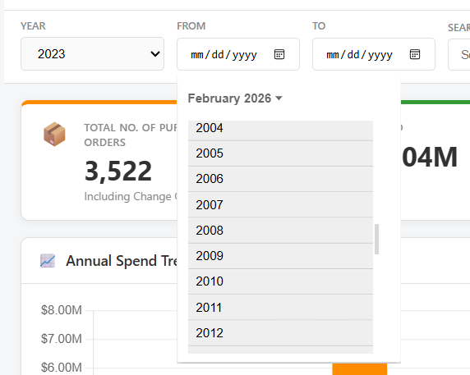

- When I use the search filter, it should give me some options as to what it is searching for. Currently the search function is not really indicating which data it is displaying. For instance, I have put test in the below search tab, nothing changed.
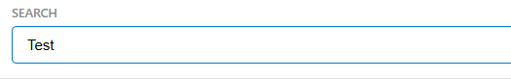
- KPIS: These KPI numbers do not match with the values mentioned in the marketplace. Are they reading from the same list? Also, the “Active Suppliers” can we rename them please “No. of Suppliers”? Also, the system is counting the no. of Active Entities but it is reading 21 entities, whereas we have 19 as part of the filters. Please recheck. Also Can we rename this field to “No. of Entities” and not “Active Entities”?

- Annual Spend Trend: This is not changing based on the filter. Also, if possible, when I click on a certain month, can I see the list of orders placed in this month in the list at the bottom of the page under “PO Details”?
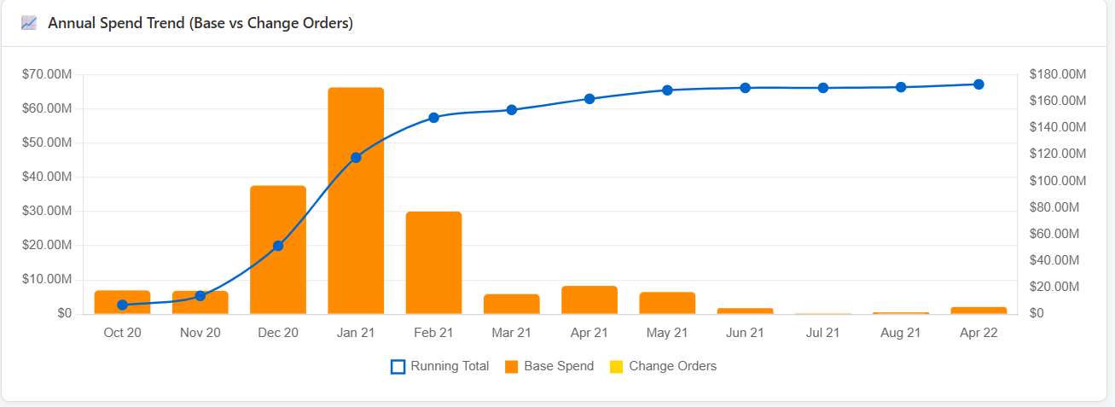

- Supplier Details:
Not showing anything for the time being. It should show the information similar to the logic under Supplier Marketplace.
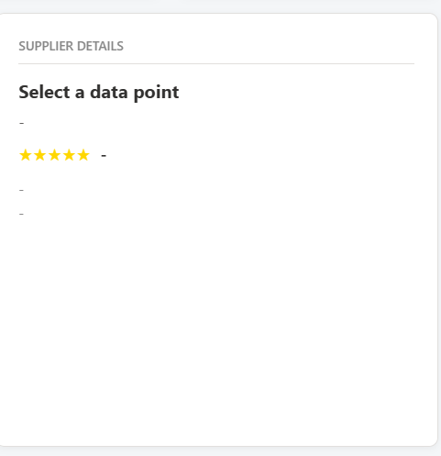

- Spend by Entity: It indicates top 5 entities by PO value, but it is listing more than 5 entities. Worth showing this data in a pie chart rather than bars. This data should also change when we filter.
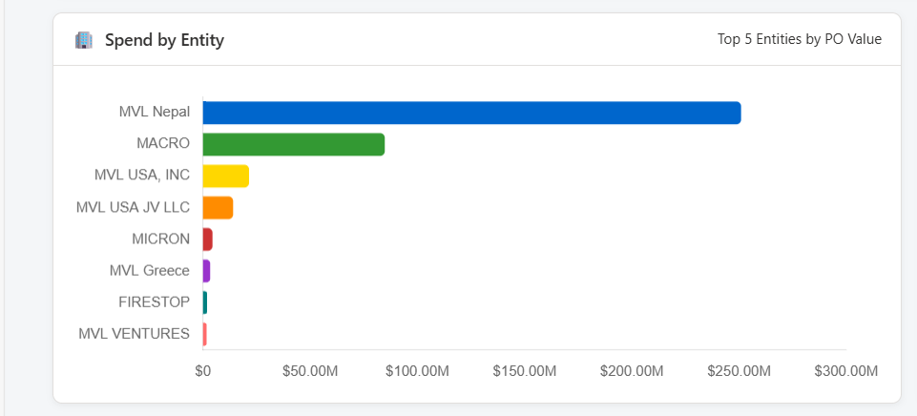

- Spend by Project: It indicates top 5 projects by PO value, but it is listing more than 5 entities. This data should also change when we filter.

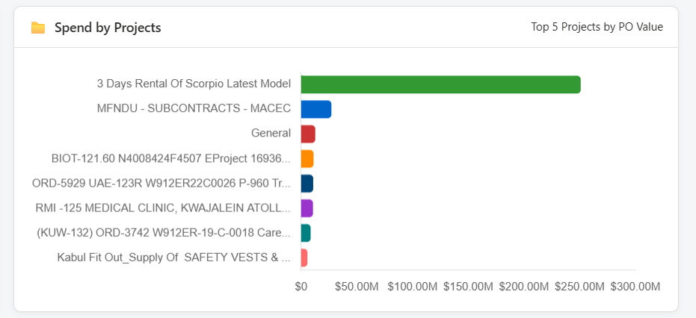

- Top Suppliers: The colors of the bars should not be the same as this indicate that the numbers are equal which is not the case. It should also be interactive, so when I click on one supplier, at least I should be having the supplier details and spend and other metrics. So this chart should also be interactive and should be able to change the other charts and metrics accordingly.
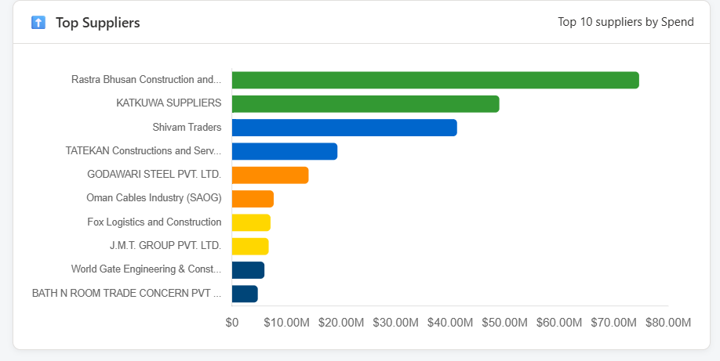

- Bottom Suppliers: The title should not be Top Suppliers, it should be “Most Inactive Suppliers”. The colors of the bars should not be the same as this indicate that the numbers are equal which is not the case. It should also be interactive, so when I click on one supplier, at least I should be having the supplier details and spend and other metrics. So this chart should also be interactive and should be able to change the other charts and metrics accordingly. Also, I wonder what are these orders for 1$. Maybe we should exclude the 1$ data. I will check the data and revert back on this one.
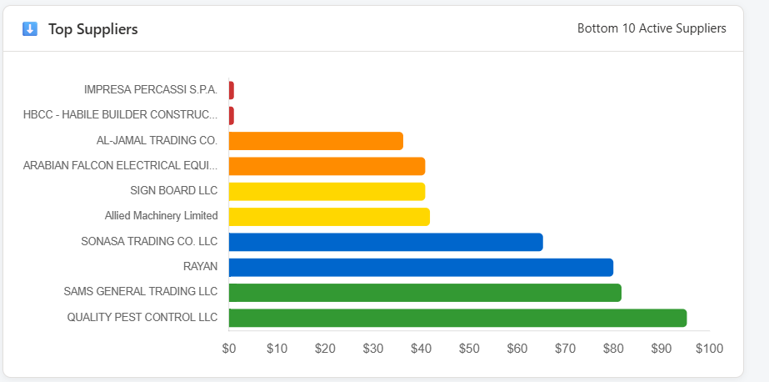
- Materials: Here Materials should be called “Disciplines” as it is reading not from the materials (30 no.) but from the disciplines (13 no.).
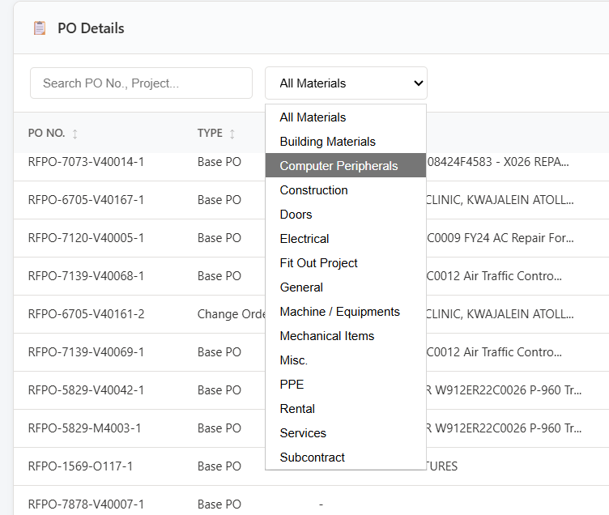

- What is this?
